DESCRIPTION

Using SQL Server MMC, create tables and indexes for storing students, subjects and classes data.

**Background of the problem statement:**

Rainbow School is creating software for school management. The first stage is to design a database in SQL Server which will manage all the data. This database will then be used in the web-based application for school management.

**You must use the following:**

SQL Server 17 Express Edition

**Tables:**

The following master tables will be created:

Student – store all student data across multiple classes

Subjects – master list of subjects taught in all classes

Classes – list of classes in the school

**Following requirements should be met:**

Some of the source code should be tracked on GitHub repositories. You need to document the tracked files that are ignored during the final push to the GitHub repository.

The submission of your GitHub repository link is mandatory. In order to track your task, you need to share the link of the repository in the document.

The step-by-step process involved in completing this task should be documented

**SOLUTION**

1)New Database

Create Database RainbowSchool

2)Create master tables

create table Student(

Student_Id int PRIMARY KEY,

First_Name varchar(40) NOT NULL,

Last_Name varchar(40),

DOB date NOT NULL,

Class_Id int REFERENCES Classes(Class_Id),

Joining_Year varchar(5),

Address varchar(60),

Blood_Group varchar(10),

Boarding bit);

create table Classes(

Class_Id int PRIMARY KEY,

Class_Name varchar(40) NOT NULL);

create table Subjects(

Subject_Id int PRIMARY KEY,

Subject_Name varchar(40) NOT NULL,

Class_Id int REFERENCES Classes(Class_Id)

);

3)Insert data

Insert into Classes values(1,'Class 1'),(2,'Class 2'),(3,'Class 3'),(4,'Class 4'),(5,'Class 5')

Insert into Subjects values(1,'Social Science',1),(2,'Maths',1),(3,'Computer Science',4),(4,'Environmental Science',5),(5,'English',3)

Insert into Student values(1,'Sahana','Nayak','1994-11-25',5,'2010','Malleshwaram,Bangalore','O+',0)

4)Query Data

select * from Classes

select * from Subjects

select * from Student

**SNAPSHOTS**

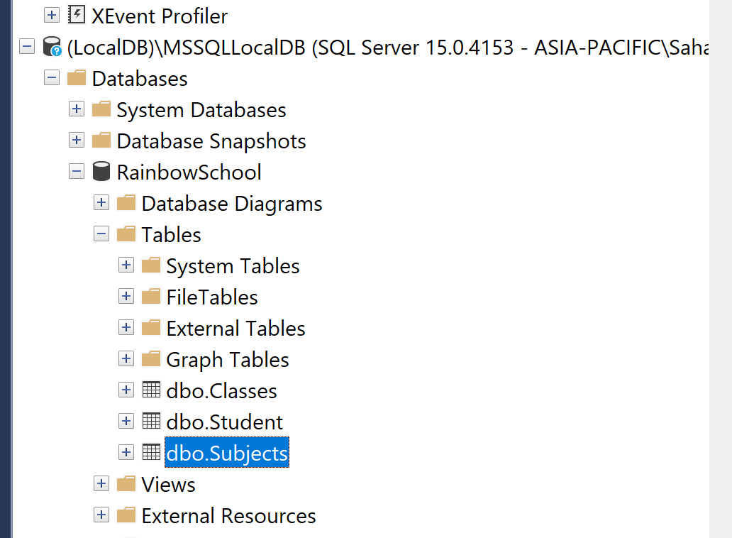

**Few data entered through UI**

